**This document contains pseudo codes for the following subroutines:**

**DisplayFullview()**

**DisplayFabricZoomIn()**

**DisplayFabricZoomOut()**

**DisplayCollar()**

**DisplayCuff()**

**DisplayButton()**

**DisplayPlacket()**

**DisplayBackYoke()**

**DisplayBackDart()**

**DisplayPlacketContrast()**

**DisplayTieFix()**

**// Subroutine : DisplayFullview()**

If (ShirtLyr01[5]==”Show”), Load and display image with filename **ShirtLyr01[0]** in folder “Shirt”

If (ShirtLyr02[5]==”Show”), Load and display image with filename **ShirtLyr02[0]** in folder “Shirt”

If (ShirtLyr03[5]==”Show”), Load and display image with filename **ShirtLyr03[0]** in folder “Shirt”

If (ShirtLyr04[5]==”Show”), Load and display image with filename **ShirtLyr04[0]** in folder “Shirt”

If (ShirtLyr05[5]==”Show”), Load and display image with filename **ShirtLyr05[0]** in folder “Shirt”

If (ShirtLyr06[5]==”Show”), Load and display image with filename **ShirtLyr06[0]** in folder “Shirt”

If (ShirtLyr07[5]==”Show”), Load and display image with filename **ShirtLyr07[0]** in folder “Shirt”

If (ShirtLyr08[5]==”Show”), Load and display image with filename **ShirtLyr08[0]** in folder “Shirt”

If (ShirtLyr09[5]==”Show”), Load and display image with filename **ShirtLyr09[0]** in folder “Shirt”

If (ShirtLyr10[5]==”Show”), Load and display image with filename **ShirtLyr10[0]** in folder “Shirt”

If (ShirtLyr11[5]==”Show”), Load and display image with filename **ShirtLyr11[0]** in folder “Shirt”

If (ShirtLyr12[5]==”Show”), Load and display image with filename **ShirtLyr12[0]** in folder “Shirt”

If (ShirtLyr13[5]==”Show”), Load and display image with filename **ShirtLyr13[0]** in folder “Shirt”

If (ShirtLyr14[5]==”Show”), Load and display image with filename **ShirtLyr14[0]** in folder “Shirt”

If (ShirtLyr15[5]==”Show”), Load and display image with filename **ShirtLyr15[0]** in folder “Shirt”

If (ShirtLyr16[5]==”Show”), Load and display image with filename **ShirtLyr16[0]** in folder “Shirt”

//Note : display the above images in layers with Lyr01 at the base and Lyr16 at the top

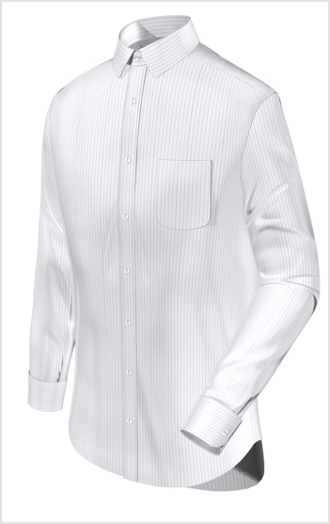

**// End of Subroutine : DisplayFullview()**

**// Subroutine : DisplayFabricZoomIn()**

If (FabricZoomIn[5]==”Show”), Load and display image with filename **FabricZoomIn[0]** in folder “Fabric”

as a overlay as shown below.

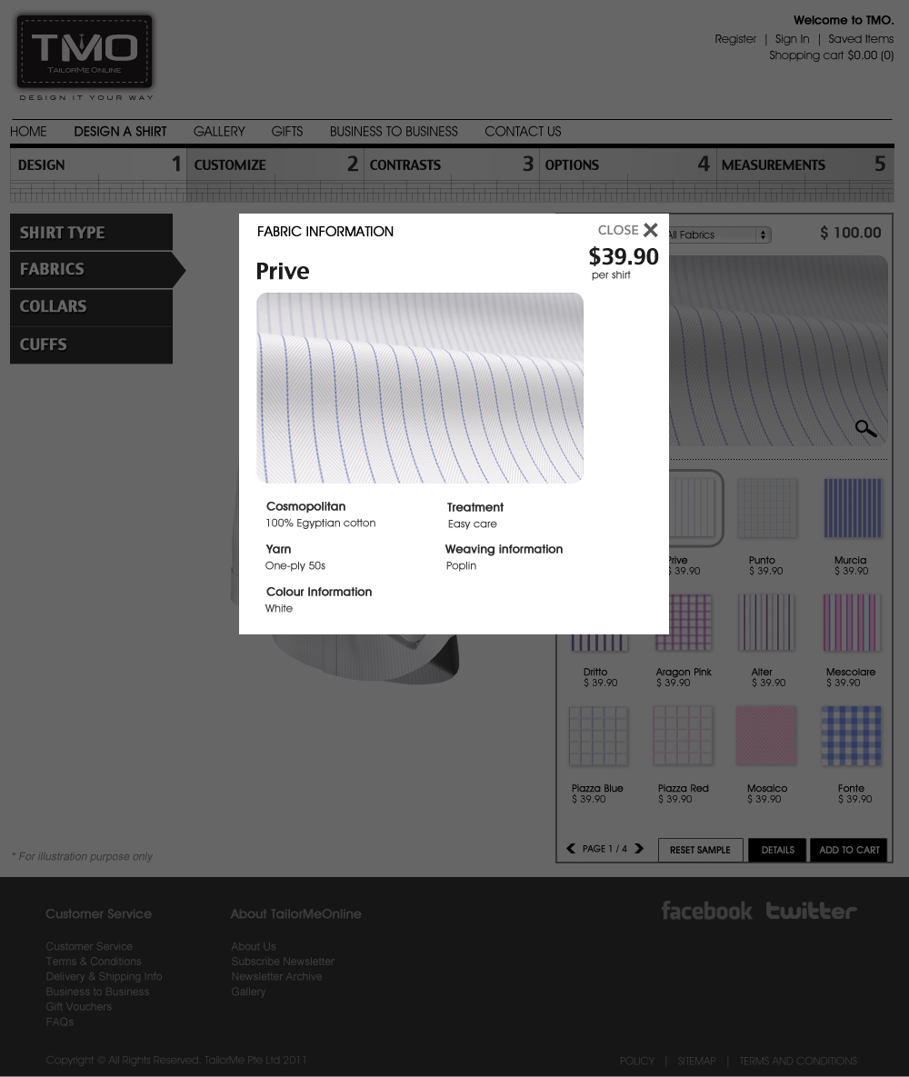

**// End of Subroutine : DisplayFabricZoomIn()**

**// Subroutine : DisplayFabricZoomOut()**

If (FabricZoomOut[5]==”Show”), Load and display image with filename **FabricZoomOut[0]** in folder “Fabric”

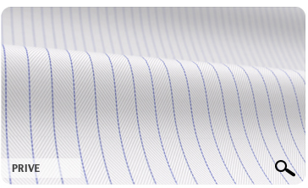

**// End of Subroutine : DisplayFabricZoomOut()**

**// Subroutine : DisplayCollar()**

If (CollarLyr01[5]==”Show”), Load and display image with filename **CollarLyr01[0]** in folder “Collar”

If (CollarLyr02[5]==”Show”), Load and display image with filename **CollarLyr02[0]** in folder “Collar”

If (CollarLyr03[5]==”Show”), Load and display image with filename **CollarLyr03[0]** in folder “Collar”

If (CollarLyr04[5]==”Show”), Load and display image with filename **CollarLyr04[0]** in folder “Collar”

If (CollarLyr05[5]==”Show”), Load and display image with filename **CollarLyr05[0]** in folder “Collar”

If (CollarLyr06[5]==”Show”), Load and display image with filename **CollarLyr06[0]** in folder “Collar”

If (CollarLyr07[5]==”Show”), Load and display image with filename **CollarLyr07[0]** in folder “Collar”

If (CollarLyr08[5]==”Show”), Load and display image with filename **CollarLyr08[0]** in folder “Collar”

If (CollarLyr09[5]==”Show”), Load and display image with filename **CollarLyr09[0]** in folder “Collar”

//Note : display the above images in layers with Lyr01 at the base and Lyr09 at the top

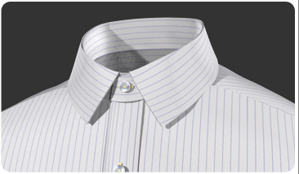

**// End of Subroutine : DisplayCollar()**

**// Subroutine : DisplayCuff()**

If (CuffLyr01[5]==”Show”), Load and display image with filename **CuffLyr01[0]** in folder “Cuff”

If (CuffLyr02[5]==”Show”), Load and display image with filename **CuffLyr02[0]** in folder “Cuff”

If (CuffLyr03[5]==”Show”), Load and display image with filename **CuffLyr03[0]** in folder “Cuff”

If (CuffLyr04[5]==”Show”), Load and display image with filename **CuffLyr04[0]** in folder “Cuff”

If (CuffLyr05[5]==”Show”), Load and display image with filename **CuffLyr05[0]** in folder “Cuff”

//Note : display the above images in layers with Lyr01 at the base and Lyr05 at the top



**// End of Subroutine : DisplayCuff()**

**// Subroutine : DisplayButton()**

If (ButtonLyr01[5]==”Show”), Load and display image with filename **ButtonLyr01[0]** in folder “Button”

If (ButtonLyr02[5]==”Show”), Load and display image with filename **ButtonLyr02[0]** in folder “Button”

If (ButtonLyr03[5]==”Show”), Load and display image with filename **ButtonLyr03[0]** in folder “Button”

//Note : display the above images in layers with Lyr01 at the base and Lyr03 at the top

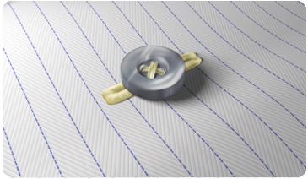

**// End of Subroutine : DisplayButton()**

**// Subroutine : DisplayPlacket()**

If (PlacketLyr01[5]==”Show”), Load and display image with filename **PlacketLyr01[0]** in folder “Placket”

If (PlacketLyr02[5]==”Show”), Load and display image with filename **PlacketLyr02[0]** in folder “Placket”

If (PlacketLyr03[5]==”Show”), Load and display image with filename **PlacketLyr03[0]** in folder “Placket”

If (PlacketLyr04[5]==”Show”), Load and display image with filename **PlacketLyr04[0]** in folder “Placket”

//Note : display the above images in layers with Lyr01 at the base and Lyr04 at the top

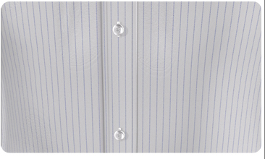

**// End of Subroutine : DisplayPlacket()**

**// Subroutine : DisplayBackYoke()**

If (BackYoke[5]==”Show”), Load and display image with filename **BackYoke[0]** in folder “Back Yoke”

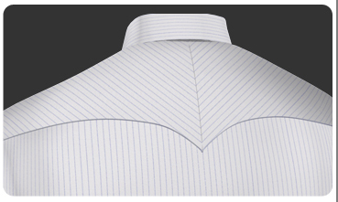

**// End of Subroutine : DisplayBackYoke()**

**// Subroutine : DisplayBackDart()**

If (BackDetails[5]==”Show”), Load and display image with filename **BackDetails[0]** in folder “Back Details”

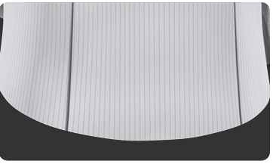

**// End of Subroutine : DisplayBackDart()**

**// Subroutine : DisplayPlacketContrast()**

If (PlacketContrastLyr01[5]==”Show”), Load and display image with filename **PlacketContrastLyr01[0]** in folder “Placket Contrast”

If (PlacketContrastLyr02[5]==”Show”), Load and display image with filename **PlacketContrastLyr02[0]** in folder “Placket Contrast”

If (PlacketContrastLyr03[5]==”Show”), Load and display image with filename **PlacketContrastLyr03[0]** in folder “Placket Contrast”

If (PlacketContrastLyr04[5]==”Show”), Load and display image with filename **PlacketContrastLyr04[0]** in folder “Placket Contrast”

If (PlacketContrastLyr05[5]==”Show”), Load and display image with filename **PlacketContrastLyr05[0]** in folder “Placket Contrast”

If (PlacketContrastLyr06[5]==”Show”), Load and display image with filename **PlacketContrastLyr06[0]** in folder “Placket Contrast”

//Note : display the above images in layers with Lyr01 at the base and Lyr06 at the top

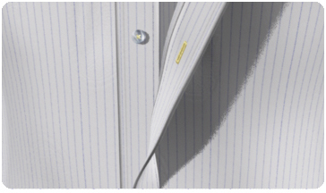

**// End of Subroutine : DisplayPlacketContrast()**

**// Subroutine : DisplayTieFix()**

If (TieFixLyr01[5]==”Show”), Load and display image with filename **TieFixLyr01[0]** in folder “Tie Fix”

If (TieFixLyr02[5]==”Show”), Load and display image with filename **TieFixLyr02[0]** in folder “Tie Fix”

If (TieFixLyr03[5]==”Show”), Load and display image with filename **TieFixLyr03[0]** in folder “Tie Fix”

If (TieFixLyr04[5]==”Show”), Load and display image with filename **TieFixLyr04[0]** in folder “Tie Fix”

If (TieFixLyr05[5]==”Show”), Load and display image with filename **TieFixLyr05[0]** in folder “Tie Fix”

//Note : display the above images in layers with Lyr01 at the base and Lyr05 at the top

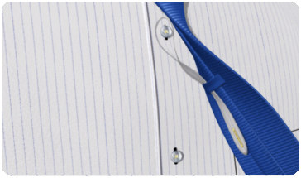

**// End of Subroutine : DisplayTieFix()**